AI Store Reality Engine
Optimizing E-commerce Stores for AI-Driven Decision-Making

Project Description
A platform that analyzes how AI systems interpret e-commerce products, identifies decision failures, and automatically optimizes content to improve AI-driven recommendations.
Team Name
- Neural Nexus

Prepared By
- Kharshavarthan N R
- Dharshini Saravanan

Hackathon
Kasparro Hackathon

Category
AI / E-commerce / SaaS Platform

Date
30/04/2026

“Bridging the gap between human-readable product content and machine-interpretable intelligence.”
Introduction
Overview
AI Store Reality Engine is a scalable SaaS platform designed to analyze and optimize how artificial intelligence systems interpret e-commerce product data. With the growing adoption of AI-driven search and recommendation systems, product visibility is increasingly determined by how effectively product information can be understood and processed by AI models.
Traditional e-commerce content is primarily optimized for human users, often relying on unstructured and ambiguous descriptions. While this approach is effective for marketing, it introduces challenges for AI systems that depend on explicit, structured, and semantically clear information for accurate decision-making.
AI Store Reality Engine addresses this gap by combining multi-agent AI simulation, explainable decision analysis, and automated content optimization. The platform enables merchants to observe how AI systems evaluate their products, identify failure points in the decision pipeline, and enhance product content to improve interpretability and recommendation outcomes.
Objective
The primary objectives of the system are:
- To simulate real-world AI-driven product evaluation using multiple AI agents
- To analyze how product data is processed within AI decision pipelines
- To identify gaps in clarity, completeness, and semantic structure
- To automatically optimize product content for improved AI interpretability
- To provide measurable insights into AI recommendation confidence
Scope
The system focuses on bridging the gap between human-readable product descriptions and machine-interpretable representations. It supports end-to end processing, including product input, AI-based evaluation, failure analysis, content optimization, and re-evaluation.
System Architecture
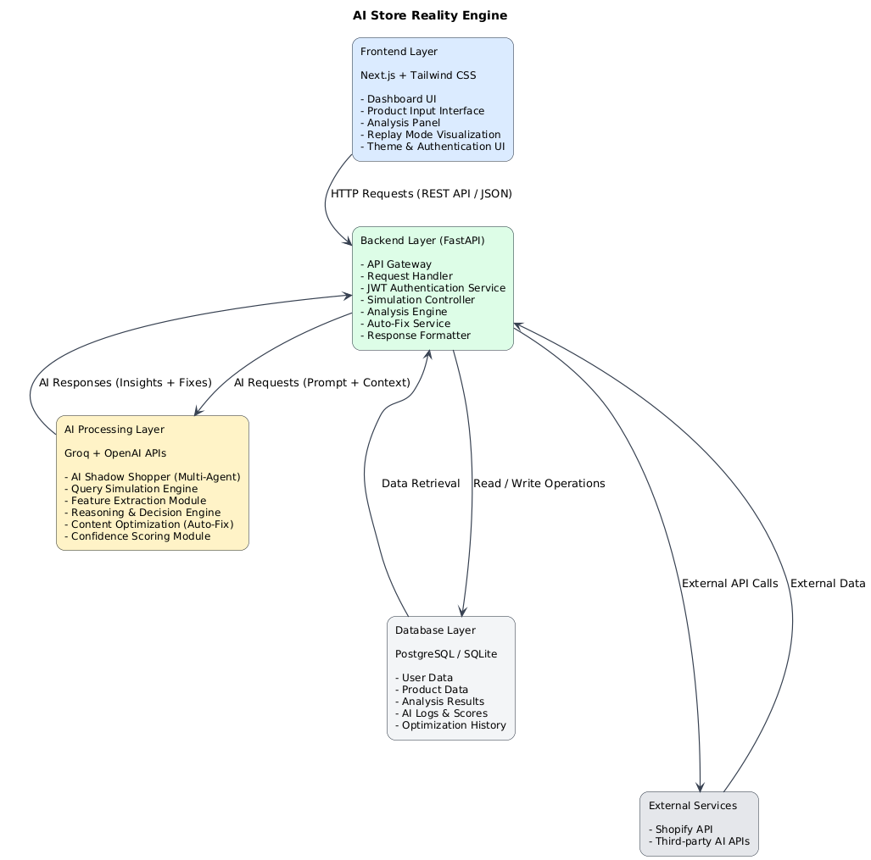
AI Processing Pipeline
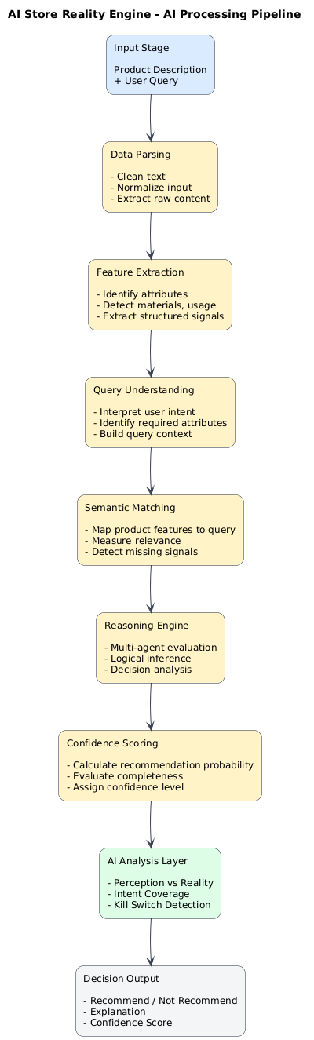
Auto-Fix Pipeline
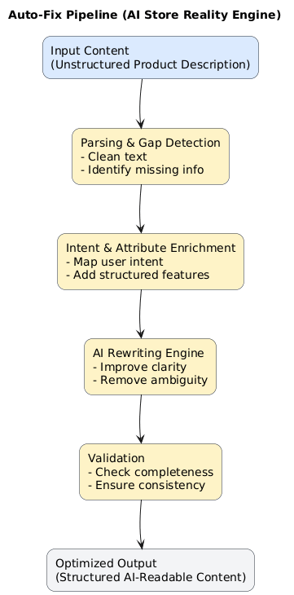
Sequence Diagram (End-to-End Request Flow)

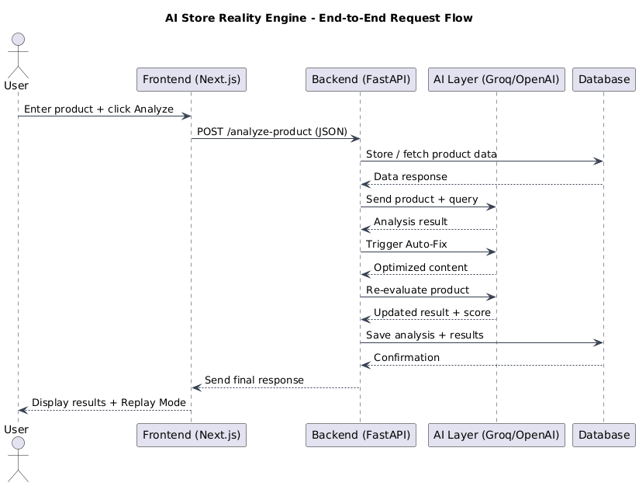

Deployment Architecture
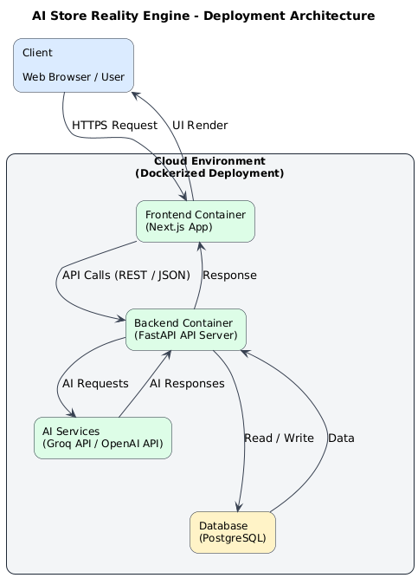

System Components
AI Store Reality Engine is composed of four core components, each responsible for a specific layer of functionality. The system is designed using a modular architecture to ensure scalability, maintainability, and clear separation of concerns.
Frontend Layer (Next.js)
Overview
The frontend provides the user interface for interacting with the system. It is built using Next.js and Tailwind CSS, offering a responsive and modern SaaS dashboard experience.
Responsibilities
- User authentication (login/signup)
- Product input and submission
- Display of AI analysis results
- Visualization of Replay Mode and metrics
Key Features
- Interactive dashboard
- Real-time result updates
- Light and dark mode support
- Clean and intuitive UI components
Backend Layer (FastAPI)
Overview
The backend acts as the core processing unit of the system. It is implemented using FastAPI, which provides high-performance API handling and asynchronous processing.
Responsibilities
- API request handling and routing
- Business logic execution
- Orchestration of AI workflows
- Communication with database and AI services
Core Modules
- Authentication Service (JWT-based security)
- Simulation Controller (AI Shadow Shopper execution)
- Analysis Engine (insight generation)
- Auto-Fix Service (content optimization)

AI Processing Layer (Groq + OpenAI)
Overview
The AI layer powers all intelligent functionalities of the system, including simulation, reasoning, and content transformation.
Technologies Used
- Groq API → fast inference and simulation
- OpenAI API → advanced reasoning and rewriting
Responsibilities
- Multi-agent simulation of AI buyers
- Feature extraction from product content
- Query understanding and matching
- Decision-making and confidence scoring
- Automated content optimization

Database Layer (PostgreSQL / SQLite)
Overview
The database layer is responsible for storing all persistent data required by the system.
Responsibilities
- Store user credentials and session data
- Maintain product information
- Save AI analysis results and logs
- Track optimization history and scores
Data Types
- Structured product data
- AI-generated insights
- Performance metrics
Component Interaction Summary
All components interact through well-defined interfaces:
- The frontend communicates with the backend via REST APIs
- The backend processes requests and coordinates with the AI layer
- The AI layer performs computation and returns results
- The database ensures persistent storage and retrieval

API Design Overview
The AI Store Reality Engine exposes a set of RESTful APIs that enable communication between the frontend, backend, and AI processing layers. These APIs are designed to be scalable, stateless, and JSON-driven, ensuring seamless integration and efficient data exchange.
All endpoints follow standard HTTP methods and return structured JSON responses for consistency and ease of use.
Endpoint: Analyze Product

POST /analyze-product
Description
This endpoint initiates the AI analysis pipeline. It processes product data, triggers AI Shadow Shopper simulation, and generates insights such as recommendation outcome, confidence score, and analysis results.

Request Body (JSON)
{
"product_name": "Running Shoes",
"description": "Premium running shoes with excellent comfort",
"user_query": "Is this suitable for marathon training?"
}

Response (JSON)
{
"status": "success",
"recommendation": "Not Recommended",
"confidence_score": 42,
"analysis": {
"missing_attributes": ["durability", "breathability"],
"perception": "Generic product",
"intent_match": "Low"
}
}
Key Functions
- Triggers AI simulation
- Performs feature extraction and reasoning
- Generates analysis insights
Endpoint: Auto-Fix Content

POST /auto-fix
Description
This endpoint optimizes product content using AI. It enhances clarity, adds structured attributes, and improves alignment with user queries.

Request Body (JSON)
{
"description": "Premium running shoes with excellent comfort"
}

Response (JSON)
{
"status": "success",
"optimized_description": "Lightweight running shoes with breathable mesh, cushioned sole, designed for long-distance running and marathon training."
}

Key Functions
- Detects missing information
- Rewrites content using AI
- Improves semantic clarity

Endpoint: Get Results
GET /results
Description
Retrieves stored analysis results and AI insights for previously processed products.

Response (JSON)
{
"status": "success",
"results": [
{
"product_name": "Running Shoes",
"confidence_score": 85,
"recommendation": "Recommended"
}
]
}

Key Functions
- Fetches historical data
- Displays performance metrics
- Supports dashboard visualization

Endpoint: User Authentication
POST /auth/login
Description
Handles user authentication and generates a JWT token for secure access to protected endpoints.

Request Body (JSON)
{
"email": "user@example.com",
"password": "securepassword"
}
Response (JSON)
{
"access_token": "jwt_token_here",
"token_type": "bearer"
}

Key Functions
- Validates user credentials
- Generates secure session token
- Enables protected API access

Data Format and Communication
Format
- All API communication uses JSON
- Requests and responses follow a structured schema
Standards
- HTTP status codes (200, 400, 401, 500)
- RESTful design principles
- Stateless communication

9.6 Error Handling
The system provides standardized error responses:
{
"status": "error",
"message": "Invalid input data"
}
Common Errors
- Invalid request format
- Unauthorized access
- AI processing failure

API Design Considerations
- Designed for scalability and extensibility
- Supports asynchronous processing
- Ensures separation between frontend and AI logic
- Enables easy integration with third-party systems

AI Trust Score Overview
The AI Trust Score is a quantitative metric that represents how effectively a product is understood and evaluated by AI systems. It measures the level of confidence an AI model has in recommending a product based on its content quality and interpretability.
This score transforms subjective analysis into a measurable indicator, enabling merchants to track and improve their product’s AI readiness.
Purpose
The AI Trust Score is designed to:
- Provide a clear indicator of AI recommendation confidence
- Identify weaknesses in product content
- Enable comparison before and after optimization
- Support data-driven decision-making

Evaluation Parameters
The score is computed based on multiple factors that influence AI interpretation:
1. Clarity
- Measures how clearly the product description communicates its purpose
- Detects ambiguity and vague language
2. Completeness
- Evaluates whether all necessary attributes are present
- Includes specifications, use-case, and performance details
3. Consistency
- Checks alignment between different parts of the content
- Ensures no conflicting or misleading information
4. Relevance
- Measures how well the product aligns with user queries
- Evaluates semantic match between content and intent

Scoring Mechanism
Each parameter contributes to the final score:
- Individual scores are calculated for each factor
- Weighted aggregation produces the final score
- Output is normalized to a scale of 0–100
Example Formula (Conceptual)
AI Trust Score =
(Clarity × 0.25) +
(Completeness × 0.30) +
(Consistency × 0.20) +
(Relevance × 0.25)
Output Interpretation
Score Range | Interpretation
0 – 40 | Low confidence (unlikely to be recommended)
41 – 70 | Moderate confidence (partial understanding)
71 – 100 | High confidence (strong recommendation likelihood)

Before vs After Optimization
The AI Trust Score is particularly useful for measuring improvement:
Stage | Score | Outcome
Before Auto-Fix | 42 | Not Recommended
After Auto-Fix | 85 | Recommended
Technical Implementation
- Scores are generated using AI-driven evaluation
- NLP techniques are used to analyze semantic clarity and structure
- Results are aggregated and stored in the database
- Displayed in the dashboard for user interpretation

Key Benefits
- Converts AI behavior into measurable data
- Enables continuous optimization
- Provides actionable insights
- Simplifies performance tracking

Security Overview
Security is a critical aspect of AI Store Reality Engine, ensuring that user data, API access, and system operations are protected from unauthorized access and misuse. The system implements standard security practices across authentication, communication, and data validation.

Authentication (JWT-Based)
The system uses JSON Web Token (JWT) authentication to manage secure user sessions.
Key Features
- Token-based authentication after login
- Stateless session management
- Secure access to protected endpoints
Workflow
- User logs in with credentials
- Backend validates user
- JWT token is generated
- Token is used in subsequent API requests

Secure API Communication
All communication between frontend, backend, and external services is secured.
Practices
- HTTPS-based communication
- Encrypted data transfer
- Protected API endpoints
Input Validation
To prevent invalid or malicious data, all inputs are validated at the backend.
Validation Includes
- Required field checks
- Data type validation
- Length and format constraints
Access Control
- Restricted endpoints require authentication
- Role-based access can be extended (future scope)
- Unauthorized requests are blocked
Error Handling and Protection
- Standardized error responses
- Sensitive information is not exposed in API responses
- Prevents system-level data leakage
Key Security Benefits
- Ensures safe user authentication
- Protects data integrity
- Prevents unauthorized access
- Supports secure system operation

Performance Overview
AI Store Reality Engine is designed to handle real-time product analysis efficiently, even with computationally intensive AI operations. The system incorporates optimized API handling, fast AI inference, and efficient data processing to ensure low latency and smooth user experience.
Fast AI Inference (Groq Integration)
The system leverages Groq API for high-speed AI inference during simulation and evaluation.
Benefits
Reduced response time for AI analysis
Faster multi-agent simulation (Shadow Shopper)
Improved real-time user interaction
Asynchronous Backend Processing
The backend uses asynchronous request handling (FastAPI async features) to manage multiple requests efficiently.
Advantages
- Non-blocking API execution
- Ability to handle concurrent users
- Improved scalability under load
Efficient API Communication
- Lightweight JSON-based requests and responses
- Minimal payload design to reduce overhead
- Optimized request-response cycles
Database Optimization
- Indexed queries for faster data retrieval
- Efficient read/write operations
- Structured storage for analysis results

Caching Strategy (Optional Enhancement)
- Frequently accessed results can be cached
- Reduces repeated AI calls
- Improves response time
Performance Optimization Techniques
- Parallel AI request handling (where applicable)
- Reduced redundant computations
- Optimized data flow between components
Key Performance Benefits
- Low latency in AI-driven operations
- Smooth user experience
- Efficient handling of multiple requests
- Scalable performance for production use
Scalability Overview
AI Store Reality Engine is designed with scalability in mind, enabling the system to handle increasing numbers of users, products, and AI requests without degradation in performance. The architecture follows a modular and service-oriented approach, allowing individual components to scale independently.
Modular Architecture
The system is divided into distinct layers:
- Frontend
- Backend
- AI Processing Layer
- Database
Benefits
- Each component can be scaled independently
- Easier maintenance and upgrades
- Clear separation of concerns
Independent Service Scaling
Each service can be scaled based on demand:
- Frontend → Scaled via CDN or edge deployment (e.g., Vercel)
- Backend → Horizontally scaled using multiple API instances
- AI Layer → Scaled through external API capacity (Groq/OpenAI)
- Database → Scaled using replication or managed services
Containerized Deployment
The system supports Docker-based deployment.
Advantages
- Consistent environment across development and production
- Easy replication of services
- Simplified scaling using container orchestration
Cloud-Ready Infrastructure
The architecture is compatible with cloud platforms such as:
- AWS
- Vercel
- Render
Capabilities
- Auto-scaling based on traffic
- Load balancing across services
- High availability and fault tolerance
Load Handling Strategy
- Asynchronous request handling
- Efficient API design
- Reduced bottlenecks in AI processing

Future Scalability Enhancements
- Microservices architecture
- Queue-based processing (e.g., background jobs)
- Distributed AI processing
Key Scalability Benefits
- Supports growing user base
- Handles large product datasets
- Enables real-time AI processing at scale
- Ready for production deployment

Replay Mode Timeline Diagram
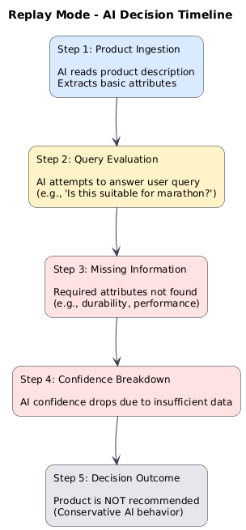
Conclusion
The Replay Mode feature provides a transparent view into the AI decision-making process, revealing how products are evaluated step by step. By exposing critical failure points—such as missing attributes or low confidence—it enables users to understand why a product is not recommended.
This insight shifts the approach from guesswork to informed optimization, allowing merchants to systematically improve their product content. As a result, Replay Mode not only enhances explainability but also plays a key role in driving better AI-driven outcomes.

